Module 4
Assessment Questions:
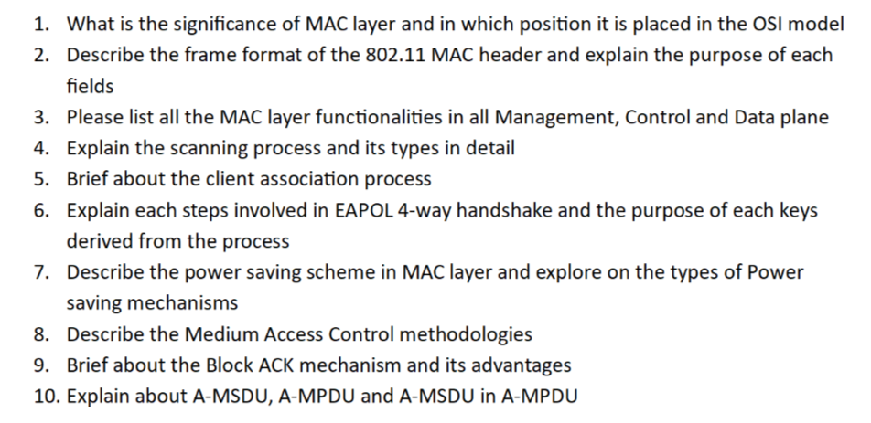
Answers :

1. Significance of MAC Layer and Its Position in the OSI Model

Position in OSI Model
The MAC (Medium Access Control) layer is a sublayer of the Data Link Layer (Layer 2) in the OSI model.
Layer 7 - Application
Layer 6 - Presentation
Layer 5 - Session
Layer 4 - Transport
Layer 3 - Network
Layer 2 - Data Link
├── LLC
└── MAC
Layer 1 - Physical

Significance of MAC Layer
The MAC layer is responsible for controlling how devices access the wireless medium.

Primary Responsibilities
- Frame encapsulation
- Addressing using MAC addresses
- Error detection
- Medium access coordination
- Fragmentation and reassembly
- Retransmissions
- QoS implementation
- Security handling

Why MAC is Important in WLAN
Unlike wired networks, wireless devices share the same radio medium.
The MAC layer ensures:
- Fair medium access
- Collision avoidance
- Efficient transmission
- Reliable delivery
- Secure communication

2. 802.11 MAC Header Frame Format and Field Purpose

Standard MAC Frame Structure

| Frame Control | Duration | Address 1 | Address 2 | Address 3 |

| Sequence Control | Address 4 | QoS Control | HT Control | Frame Body | FCS |

Detailed Field Explanation

Frame Control (2 Bytes)
Contains:
- Protocol version
- Type
- Subtype
- To DS
- From DS
- More Fragments
- Retry
- Power Management
- More Data
- Protected Frame
- Order

Duration/ID (2 Bytes)
- Reserves medium using NAV.
- Used for power-saving stations.

Address Fields
- Address 1: Receiver Address
- Address 2: Transmitter Address
- Address 3: Destination or BSSID
- Address 4: Used in WDS only

Sequence Control
- Sequence Number
- Fragment Number
Helps in ordering and duplicate detection.

QoS Control
- Traffic priority
- TID
- EOSP

HT Control
- Used in high-throughput operations.

3. MAC Layer Functionalities in Management, Control and Data Planes

Management Plane
Responsible for network establishment and maintenance.

Functions
- Beacon transmission
- Probe request/response
- Authentication
- Association
- Reassociation
- Deauthentication
- Disassociation
- Scanning
- Roaming

Control Plane
Responsible for medium coordination.

Functions
- RTS
- CTS
- ACK
- Block ACK
- PS-Poll
- CF-End
- BAR (Block ACK Request)

Data Plane
Responsible for user traffic delivery.

Functions
- Data transmission
- Frame aggregation
- Encryption
- Fragmentation
- Retransmission
- QoS scheduling

Frame Check Sequence (FCS)
- CRC-based error detection.

4. Scanning Process and Its Types

Purpose
Scanning allows clients to discover available wireless networks.

Types of Scanning

Passive Scanning
- Client listens for beacons.
- No transmission required.

Advantages
- Low overhead
- Standard compliant

Disadvantages
- Slower discovery

Active Scanning
- Client sends Probe Request.
- AP responds with Probe Response.

Advantages
- Faster discovery

Disadvantages
- More airtime usage

Scanning Steps
- Select channel
- Listen or transmit probe
- Receive responses
- Store AP information
- Move to next channel
- Choose best AP

5. Client Association Process

Complete Workflow

Step 1: Scanning
Client discovers APs.

Step 2: Authentication
Open System Authentication.

Step 3: Association Request
Client sends capabilities and supported rates.

Step 4: Association Response
AP assigns Association ID (AID).

Step 5: Security Handshake
EAPOL 4-way handshake occurs.

Step 6: DHCP
Client obtains IP address.

6. EAPOL 4-Way Handshake and Key Purpose

Purpose
- Verify PMK possession
- Generate session keys
- Install encryption keys

Keys Involved
- PMK (Pairwise Master Key)
- PTK (Pairwise Transient Key)
- GTK (Group Temporal Key)

Handshake Steps

Message 1
AP sends ANonce.

Message 2
Client generates SNonce, derives PTK, sends MIC.

Message 3
AP verifies PTK, sends GTK encrypted.

Message 4
Client acknowledges successful installation.

PTK Components
- KCK: Key Confirmation Key
- KEK: Key Encryption Key
- TK: Temporal Key

7. Power Saving Schemes in MAC Layer

Purpose
Reduce battery consumption.

Legacy Power Save
- Client sleeps.
- AP buffers frames.
- Beacon indicates pending data.
- Client sends PS-Poll.

U-APSD
- Automatic delivery upon trigger frame.

TWT (Target Wake Time)
- Scheduled wake-up intervals.
- Major Wi-Fi 6 enhancement.

Benefits
- Extended battery life
- Reduced contention
- Improved efficiency

8. Medium Access Control Methodologies

CSMA/CA
Carrier Sense Multiple Access with Collision Avoidance.

Working
- Sense channel.
- If idle, wait DIFS.
- Start random backoff.
- Transmit when timer reaches zero.
- Receive ACK.

Optional RTS/CTS
Used to avoid hidden node problems.

Why Not CSMA/CD?
Wireless devices cannot detect collisions while transmitting.

9. Block ACK Mechanism and Advantages

Traditional ACK
Each frame acknowledged individually.

Block ACK
Multiple frames acknowledged together.

Process
- Sender transmits burst.
- Receiver sends bitmap acknowledgment.

Advantages
- Reduced overhead
- Higher throughput
- Better efficiency
- Lower latency

10. A-MSDU, A-MPDU and A-MSDU within A-MPDU

A-MSDU

Definition
Multiple MSDUs combined into one MPDU.

Advantages
- Reduced MAC header overhead.

Limitation
- Entire aggregate retransmitted if corrupted.

A-MPDU

Definition
Multiple MPDUs combined into one transmission.

Advantages
- Selective retransmission.
- Better reliability.

A-MSDU within A-MPDU

Hybrid Aggregation
- Multiple MSDUs inside each MPDU.
- Multiple MPDUs aggregated together.

Comparison
Feature | A-MSDU | A-MPDU
Efficiency | Higher | High
Reliability | Lower | Higher
Retransmission | Entire Aggregate | Individual MPDU

Benefits of Hybrid Aggregation
- Maximum throughput
- Efficient airtime utilization
- Improved reliability
- Used extensively in modern Wi-Fi standards

